

**ADVANCED PLACEMENT EXAMS 2025**

**INDORE, INDIA**

**TEST CENTER: THE EMERALD HEIGHTS INTERNATIONAL SCHOOL**

**Center Address: OPP. AKASHWANI, AB ROAD, RAU, INDORE.**

**AP Coordinator: VANDANA MURJANI**

**AP Coordinator's Email Address:** [vandana.murjani@emeraldheights.edu.in](mailto:vandana.murjani@emeraldheights.edu.in)

**AP Coordinator's Contact Phone:** 9425009942, 6262045310

**Contact Hours:** Monday to Friday: 3:00 pm to 4:00 pm

**Registration & Payment Deadline*: Registration opens on September 16th, 2024.******Deadline to pay and register is Nov.7th, 2024***

Register for regular (May 5th, 2025 -May 16th, 2025). **PLEASE NOTE: OUR CENTER IS CLOSED FOR LATE TESTING**

**AP Exam Fee:** Registration Fee INR 13,500 **/-** per AP Exam

**Refund Policy:** ***NO REFUND******IN THE EVENT OF CANCELLATIONS OR NO SHOW***

**REGISTRATION & PAYMENT INSTRUCTIONS**

**Complete ALL STEPS BELOW (register online and pay the test center) by November 7th, 2024 to reserve your seat. The Test Center will provide an AP Admission Ticket by JAN 15TH, 2025, as a confirmation that your seat is reserved.**

***IF YOU REGISTER ONLINE WITH THE COLLEGE BOARD BUT DO NOT PAY THE TEST CENTER, YOU WILL NOT BE ABLE TO TEST.***

***IF YOU PAY BUT DO NOT COMPLETE ONLINE REGISTRATION, YOU WILL NOT BE ABLE TO TEST.***

**TO START: Use a phone, tablet, or computer to complete registration online with the College Board (Steps** ➊ -➎)

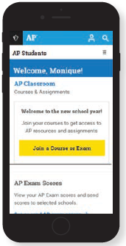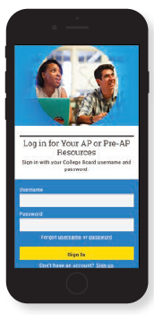

➊ Sign in to **myap.collegeboard.org** using the same College Board student account login you have used to view AP, SAT, or PSAT scores, or to register for the SAT.

🛈 Forgot your login info? Follow the “Forgot username or password?” links to reset them.

🛈 Don’t have a student account yet? Click the **Sign up** link. **IMPORTANT:** Create your College Board account using the same email you will provide to the test center. 🛈 Having technical issues? Contact AP: Inquiry Form: [cb.org/apstudentinquiry](http://cb.org/apstudentinquiry) *Live Chat available <https://apstudents.collegeboard.org/> during AP Program business hours * Phone: +1 212-632-1780

➋ JOIN AN EXAM

Click the **Join a Course or Exam** button.

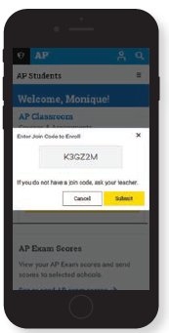

➌ SUBMIT YOUR JOIN CODE

Check the India AP Exam schedule on <http://ap-india.org>. Enter the unique join code for each testing exam you wish to take at this test center and click **Submit**. (Repeat for each exam you wish to take.)

|  |  |  |
| --- | --- | --- |
| **REGULAR TESTING: MAY 5th, 2025 – MAY 16th, 2025 (SELECT THE APPROPRIATE CODE)** | | |
| **AP Biology( Digital): M77ER2**  **AP Calculus AB( Hybrid): VMQV2Q**  **AP Calculus BC(Hybrid)) : J64NLL**  **AP Chemistry ( Hybrid): 3PPWDL** | **AP Statistics ( Hybrid): Y2PAL9**  **AP Macroeconomics ( Hybrid) ZAV4PL**  **AP Microeconomics( Hybrid) PE7G2E**  **AP Psychology ( Digital): NVJ3PX** | **AP Physics C: E &M( Hybrid) 74VG7R**  **AP Physic C: Mechanics(Hybrid) 9M4WN6**  **AP Comp Science A( Digital): 79GQ3A** |

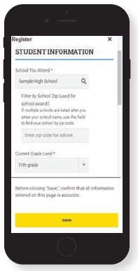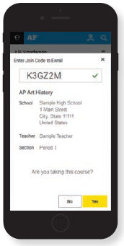

➍ VERIFY EXAM

INFORMATION

Confirm the exam name, exam date, and test center name are what you want.

Click the **Join a Course or Exam** button.

➎ FILL OUT REGISTRATION

INFORMATION

The first time you register in My AP, you’ll need to fill out some registration information. Provide accurate information – this will be on your personalized AP labels for exam day. You only have to do this once.

Repeat steps ➋ - ➍ for each exam you wish to take.



➏ PAY TEST CENTER WITHIN 3 BUSINESS DAYS OF COMPLETING ONLINE REGISTRATION by Nov 7th, 2024, WHICHEVER COMES FIRST. EMAIL YOUR PAYMENT DETAILS TO THE TEST CENTER COORDINATOR SO THAT THE TEST CENTER MAY MATCH YOUR PAYMENT TO YOUR ONLINE REGISTRATION.

**FILL IN THE INFO BELOW AND EMAIL TO THE TEST CENTER COORDINATOR:**

* Student First Name: ___________________________________________________________
* Student Last Name: ___________________________________________________________
* Student Primary Email (same as on your College Board account): _________________________________
* Student Mobile: __________________________
* Student Home City: _________________ Country________________
* School you are currently enrolled in: _________________
* Which curriculum are you currently enrolled in: ___________
* Which grade will you be in as on 1st May 2025?
* Student Date of Birth (DD/MM/YYYY): __________________ (see age acknowledgement below)*
* AP ID ( locate in your AP profile on your Collegeboard Account) ________________________
* List All Exams You Registered for Online: 
  + **Regular Exam date MAY (5-9, 12-16) 2025**: _________________________________________

**•**  Primary Parent First Name: ___________________________________________________________

• Primary Parent Last Name: ___________________________________________________________

• Primary Parent Email: _________________________________

• Primary Parent Mobile: __________________________

***Payment can be made only by cheque*, drawn in favour of**

***Name - EMERALD  HEIGHTS INTERNATIONAL SCHOOL***

***Bank Name - Kotak Mahindra Bank***

***Bank A/C No. - 6812692341***

***IFSC - KKBK0000751***

***Branch - M.G.Road , Indore 452001 (M.P.) , India***

**The Cheque can be submitted in person, or sent by post with-Student’s Name, Father’s Name and School/City at the backside of the cheque. If sending by post, please include the printed copy of your application form, so that the payment can be matched with your registration. The envelope must mention the name of the AP coordinator in order to avoid any confusion.**

***Share with the coordinator: STUDENTS FULL NAME, DOB, FATHER’S NAME, SCHOOL’s NAME, CLASS, FEE AMOUNT PAID, with the names of subjects registered.***

***BY PAYING THE TEST CENTER, YOU ACKNOWLEDGE YOU HAVE READ AND UNDERSTAND ALL AP EXAM TEST CENTER POLICIES.***

I acknowledge that in order to take AP Exams, I am meet at least one of the eligibility categories below:

* Students who are actively enrolled in secondary school.
* Secondary school-level students who are homeschooled, participate in independent study, or attend a virtual school.
* Actively enrolled students who may be prepared to take an AP Exam prior to the ninth grade.
* Recent secondary school graduates who need a specific AP exam for university admission.
* I acknowledge that I meet the student eligibility criteria and have a legitimate need for AP testing. I acknowledge that I have read and agree to test center policies above, with respect to payment deadline, payment instructions, refunds and cancellations.
* I acknowledge that I will bring the hard copy of the Admission Ticket along with the physical, original, VALID PASSPORT to the test center on exam day, or I will not be able to test.
* I acknowledge that if original, valid passport is not available, then I must have the Aadhaar in either original PVC version with hologram only (both received from UIDAI)
* I acknowledge that I will bring an Approved Testing Device to the test centre on the exam day.
* I acknowledge that if I do not meet the above eligibility requirement and have a legitimate need for AP testing, I must request approval via email from College Board at aptestsecurity@collegeboard.org, prior to registering with a test center.
* I acknowledge that it is my responsibility to register for the exam in MYAP using a join code and to pay The Emerald Heights International School Test Center directly for the exams. If I fail to register and pay, The Emerald Heights International School will not be responsible, and I will not be able to take the test.
* I understand that it is my responsibility to pay The Emerald Heights International School Test Center and complete the exam registration in MYAP. If I do not complete the payment and registration, I will not be able to take the test, and no refund will be provided. I acknowledge that The Emerald Heights International School, as the test center, will not be held responsible if I am unable to test.

**STUDENT NAME : STUDENT SIGNATURE:**

**PARENT NAME : PARENT SIGNATURE:**